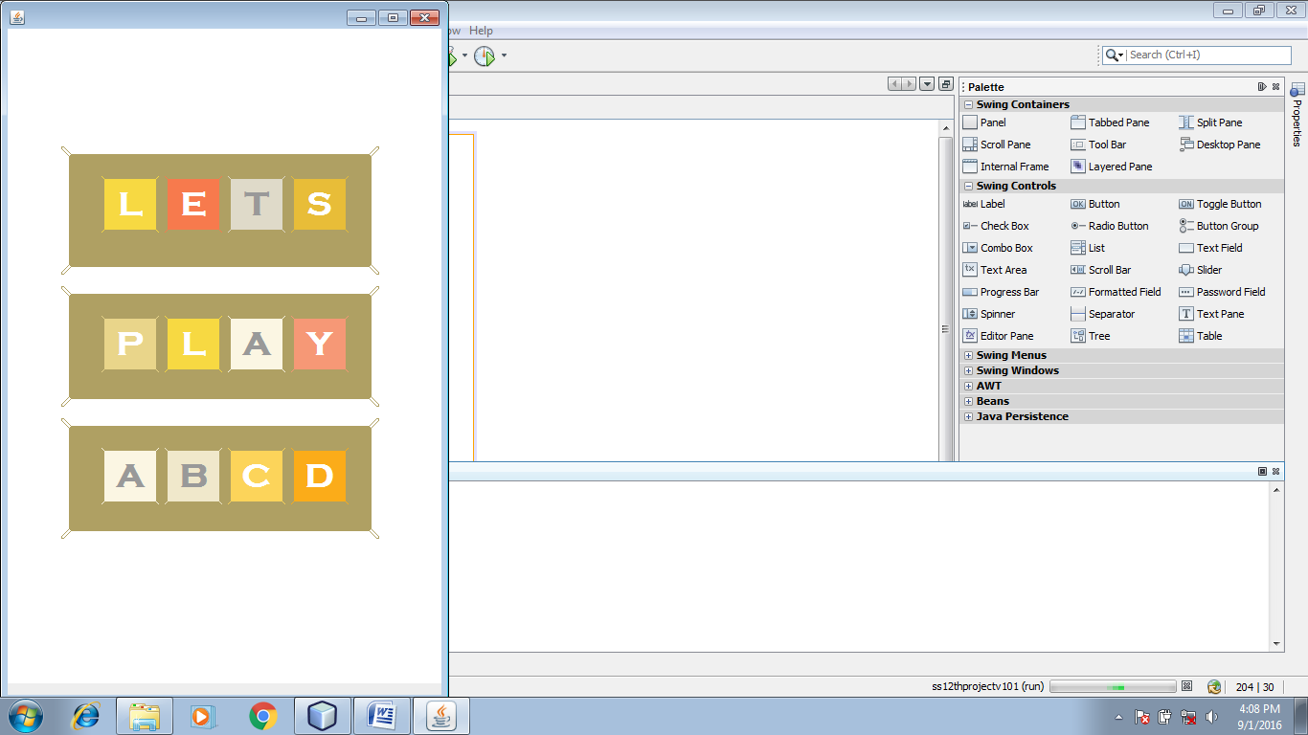Imported Packages

import java.awt.Color;

import java.sql.*;

import javax.swing.JOptionPane;

import java.util.*;

Global Declaration

String [] [] colour = new String [4] [4];

String [] [] colour1 = new String [4] [4];

char[][]index=new char[4][4];

char[][]index1=new char[4][4];

long score ;

int direction;

boolean testCombine [] [] = new boolean[4][4];

Timer delay1;

Timer delay2;

Timer delay3;

Functions

public void colourAllot(int a,int b,char c) {

switch(c) {

case 'A': colour[a][b] = "0xFDF6E3";//251,246,227

colour1[a][b] = "0x999999";//153,153,153

break;

case 'B': colour[a][b] = "0xF0E8CD";//240,232,203

colour1[a][b] = "0x999999";//153,153,153

break;

case 'C': colour[a][b] = "0xFCD45A";//252,212,90

colour1[a][b] = "0xFFFFFF";//255,255,255

break;

case 'D': colour[a][b] = "0xFDAC19";//251,172,25

colour1[a][b] = "0xFFFFFF";//255,255,255

break;

case 'E': colour[a][b] = "0xF77A4D";//247,122,77

colour1[a][b] = "0xFFFFFF";//255,255,255

break;

case 'F': colour[a][b] = "0xFDAC19";//251,172,25

colour1[a][b] = "0xFFFFFF";//255,255,255

break;

case 'G': colour[a][b] = "0xF7E642";//247,230,66

 colour1[a][b] = "0xFFFFFF";//255,255,255

break;

case 'H': colour[a][b] = "0xF7D942";//247,217,66

colour1[a][b] = "0xFFFFFF";//255,255,255

break;

case 'I': colour[a][b] = "0xFDAC19";//251,172,25

colour1[a][b] = "0xFFFFFF";//255,255,255

break;

default: colour[a][b] = "0xFFFFFF";//247,122,77

colour1[a][b]="0xFFFFFF";//255,255,255

break; }

}

public void colourAssign() {

jLabel11.setForeground(Color.decode(colour1[0][0]));

jLabel12.setForeground(Color.decode(colour1[0][1]));

jLabel13.setForeground(Color.decode(colour1[0][2]));

jLabel14.setForeground(Color.decode(colour1[0][3]));

jLabel21.setForeground(Color.decode(colour1[1][0]));

jLabel22.setForeground(Color.decode(colour1[1][1]));

jLabel23.setForeground(Color.decode(colour1[1][2]));

jLabel24.setForeground(Color.decode(colour1[1][3]));

jLabel31.setForeground(Color.decode(colour1[2][0]));

jLabel32.setForeground(Color.decode(colour1[2][1]));

 jLabel33.setForeground(Color.decode(colour1[2][2]));

jLabel34.setForeground(Color.decode(colour1[2][3]));

jLabel41.setForeground(Color.decode(colour1[3][0]));

jLabel42.setForeground(Color.decode(colour1[3][1]));

jLabel43.setForeground(Color.decode(colour1[3][2]));

jLabel44.setForeground(Color.decode(colour1[3][3]));

jLabel11.setBackground(Color.decode(colour[0][0]));

jLabel12.setBackground(Color.decode(colour[0][1]));

jLabel13.setBackground(Color.decode(colour[0][2]));

jLabel14.setBackground(Color.decode(colour[0][3]));

jLabel21.setBackground(Color.decode(colour[1][0]));

jLabel22.setBackground(Color.decode(colour[1][1]));

jLabel23.setBackground(Color.decode(colour[1][2]));

jLabel24.setBackground(Color.decode(colour[1][3]));

jLabel31.setBackground(Color.decode(colour[2][0]));

jLabel32.setBackground(Color.decode(colour[2][1]));

jLabel33.setBackground(Color.decode(colour[2][2]));

jLabel34.setBackground(Color.decode(colour[2][3]));

jLabel41.setBackground(Color.decode(colour[3][0]));

jLabel42.setBackground(Color.decode(colour[3][1]));

jLabel43.setBackground(Color.decode(colour[3][2]));

jLabel44.setBackground(Color.decode(colour[3][3]));

}

public void valueAssign () {

scoreLabel.setText(""+score);

jLabel11.setText(""+index[0][0]);

jLabel12.setText(""+index[0][1]);

jLabel13.setText(""+index[0][2]);

jLabel14.setText(""+index[0][3]);

jLabel21.setText(""+index[1][0]);

jLabel22.setText(""+index[1][1]);

jLabel23.setText(""+index[1][2]);

jLabel24.setText(""+index[1][3]);

jLabel31.setText(""+index[2][0]);

jLabel32.setText(""+index[2][1]);

jLabel33.setText(""+index[2][2]);

jLabel34.setText(""+index[2][3]);

jLabel41.setText(""+index[3][0]);

jLabel42.setText(""+index[3][1]);

jLabel43.setText(""+index[3][2]);

jLabel44.setText(""+index[3][3]);

}

 public void goUp(){

for(int j= 0; j<=3;j++){

if(index [0][j]==' '){

for(int l=0;l<3;l++) {

index[l][j]=index[l+1][j];

}

index[3][j]=' ';

}

else if(testCombine[0][j]&&testCombine[1][j]&&index [0][j]== index [1][j]) {

index[0][j]=(char)(index[1][j]+1);

index[1][j]=(char)(index[2][j]);

index[2][j]=(char)(index[3][j]);

index[3][j]=' ';

score+=(long)(Math.pow(2,index[0][j]-64));

testCombine[0][j]=false;

}

else if (index[1][j]==' '){

for(int l=1;l<3;l++){

index[l][j]=index[l+1][j];

}

index[3][j]=' ';

}

 else if(testCombine[1][j]&&testCombine[2][j]&&index [1][j]== index [2][j]) {

index[1][j]=(char)(index[2][j]+1);

index[2][j]=(char)(index[3][j]);

index[3][j]=' ';

score+=(long)(Math.pow(2,index[1][j]-64));

testCombine[1][j]=false;

}

else if (index[2][j]==' '){

for(int l=2;l<3;l++){

index[l][j]=index[l+1][j];

}

index[3][j]=' ';

}

else if(testCombine[2][j]&&testCombine[3][j]&&index [2][j]== index [3][j]) {

index[2][j]=(char)(index[3][j]+1);

index[3][j]=' ';

score+=(long)(Math.pow(2,index[2][j]-64));

testCombine[2][j] = false;

}

}

}

 public void goDown(){

for(int j= 0; j<=3;j++){

if(index [3][j]==' ') {

for(int l=3;l>0;l--){

index[l][j]=index[l-1][j];

}

index[0][j]=' ';

}

else if(testCombine[3][j]&&testCombine[2][j]&&index [3][j]== index [2][j]) {

index[3][j]=(char)(index[2][j]+1);

index[2][j]=(char)(index[1][j]);

index[1][j]=(char)(index[0][j]);

index[0][j]=' ';

score+=(long)(Math.pow(2,index[3][j]-64));

testCombine[3][j]=false;

}

else if (index[2][j]==' '){

for(int l=2;l>0;l--){

index[l][j]=index[l-1][j];

}

index[0][j]=' ';

}

 else if(testCombine[2][j]&&testCombine[1][j]&&index [2][j]== index [1][j]){

index[2][j]=(char)(index[1][j]+1);

index[1][j]=(char)(index[0][j]);

index[0][j]=' ';

score+=(long)(Math.pow(2,index[2][j]-64));

testCombine[2][j]=false;

}

else if (index[1][j]==' '){

for(int l=1;l>0;l--){

index[l][j]=index[l-1][j];

}

index[0][j]=' ';

}

else if(testCombine[1][j]&&testCombine[0][j]&&index [1][j]== index [0][j]){

index[1][j]=(char)(index[0][j]+1);

index[0][j]=' ';

score+=(long)(Math.pow(2,index[1][j]-64));

testCombine[1][j] = false;

}

}

}

public void goLeft(){

for(int i= 0; i<=3;i++){

if(index [i][0]==' '){

for(int l=0;l<3;l++){

index[i][l]=index[i][l+1];

}

index[i][3]=' ';

}

else if(testCombine[i][0]&&testCombine[i][1]&&index [i][0]== index [i][1]){

index[i][0]=(char)(index[i][1]+1);

index[i][1]=(char)(index[i][2]);

index[i][2]=(char)(index[i][3]);

index[i][3]=' ';

score+=(long)(Math.pow(2,index[i][0]-64));

testCombine[i][0]=false;

}

else if (index[i][1]==' '){

for(int l=1;l<3;l++){

index[i][l]=index[i][l+1];

}

index[i][3]=' ';

}

 else if(testCombine[i][1]&&testCombine[i][2]&&index [i][1]== index [i][2]){

index[i][1]=(char)(index[i][2]+1);

index[i][2]=(char)(index[i][3]);

index[i][3]=' ';

score+=(long)(Math.pow(2,index[i][1]-64));

testCombine[i][1]=false;

}

else if (index[i][2]==' '){

for(int l=2;l<3;l++){

index[i][l]=index[i][l+1];

}

index[i][3]=' ';

}

else if(testCombine[i][2]&&testCombine[i][3]&&index [i][2]== index [i][3]){

index[i][2]=(char)(index[i][3]+1);

index[i][3]=' ';

score+=(long)(Math.pow(2,index[i][2]-64));

testCombine[i][2] = false;

}

}

}

 public void goRight(){

for(int i= 0; i<=3;i++){

if(index [i][3]==' '){

for(int l=3;l>0;l--){

index[i][l]=index[i][l-1];

}

index[i][0]=' ';

}

else if(testCombine[i][3]&&testCombine[i][2]&&index [i][3]== index [i][2]){

index[i][3]=(char)(index[i][2]+1);

index[i][2]=(char)(index[i][1]);

index[i][1]=(char)(index[i][0]);

index[i][0]=' ';

score+=(long)(Math.pow(2,index[i][3]-64));

testCombine[i][3]=false;

}

else if (index[i][2]==' '){

for(int l=2;l>0;l--){

index[i][l]=index[i][l-1];

}

index[i][0]=' ';

}

 else if(testCombine[i][2]&&testCombine[i][1]&&index [i][2]== index [i][1]){

index[i][2]=(char)(index[i][1]+1);

index[i][1]=(char)(index[i][0]);

index[i][0]=' ';

score+=(long)(Math.pow(2,index[i][2]-64));

testCombine[i][2]=false;

}

else if (index[i][1]==' '){

for(int l=1;l>0;l--){

index[i][l]=index[i][l-1];

}

index[i][0]=' ';

}

else if(testCombine[i][1]&&testCombine[i][0]&&index [i][1]== index [i][0]){

index[i][1]=(char)(index[i][0]+1);

index[i][0]=' ';

score+=(long)(Math.pow(2,index[i][1]-64));

testCombine[i][1] = false;

}

}

}

 public void delay() {

delay1 = new Timer();

delay2 = new Timer();

delay3 = new Timer();

delay1.schedule(new execute1(), 200);

delay2.schedule(new execute1(),400);

delay3.schedule(new execute2(),600);

}

class execute1 extends TimerTask {

public void run() {

switch(direction) {

case 1: goUp();

valueAssign();

for(int i =0;i<=3;i++ ){

for(int j=0;j<=3;j++){

colourAllot(i,j,index [i][j]);

}

}

colourAssign();

break;

case 2: goDown();

valueAssign();

 for(int i =0;i<=3;i++ ){

for(int j=0;j<=3;j++){

colourAllot(i,j,index [i][j]);

}

}

colourAssign();

break;

case 3: goLeft();

valueAssign();

for(int i =0;i<=3;i++ ){

for(int j=0;j<=3;j++){

colourAllot(i,j,index [i][j]);

}

}

colourAssign();

break;

case 4: goRight();

valueAssign();

for(int i =0;i<=3;i++ ){

for(int j=0;j<=3;j++){

colourAllot(i,j,index [i][j]);

}

}

 colourAssign();

break;

}

}

}

class execute2 extends TimerTask {

public void run() {

try{

int flag=0;

for(int i=0;i<=3;i++){

for(int j=0;j<=3;j++){

if(index1[i][j]!=index[i][j])

flag = 1;

}

}

char add1=(char)(65+(int)((Math.random()*2)));

char add2=(char)(65+(int)((Math.random()*3)));

if(flag==1){

while(true){

int a=(int)((Math.random()*4));

int b=(int)((Math.random()*4));

if(index[a][b]==' '){

if (score<150)

 index[a][b]='A';

else if(score>=150&&score<500)

index[a][b]=add1;

else

index[a][b]=add2;

break;

}

}

}

valueAssign();

for(int i =0;i<=3;i++ ) {

for(int j=0;j<=3;j++) {

colourAllot(i,j,index [i][j]);

}

}

colourAssign();

Class.forName("java.sql.DriverManager");

Connection con=(Connection)DriverManager.getConnection("jdbc:mysql:// localhost:3306/project12","root","dumbo");

Statement stmt =(Statement)con.createStatement();

if(flag==1){

for(int l=0;l<16;l++){

int i=l/4;

 int j=l%4;

String query1="Update Saved_Game set previous = present where jLabelNo = '"+i+j+"';";

stmt.executeUpdate(query1);

String query="Update Saved_Game set present = '"+index[i][j]+"' where jLabelNo = '"+i+j+"';";

stmt.executeUpdate(query);

}

}

String query1="Update Saved_Game set previous = present where jLabelNo = 'sc';";

stmt.executeUpdate(query1);

String query="Update Saved_Game set present = '"+score+"' where jLabelNo = 'sc';";

stmt.executeUpdate(query);

}

catch(Exception e){

JOptionPane.showMessageDialog(this, e.getMessage());

}

}

}

Title Frame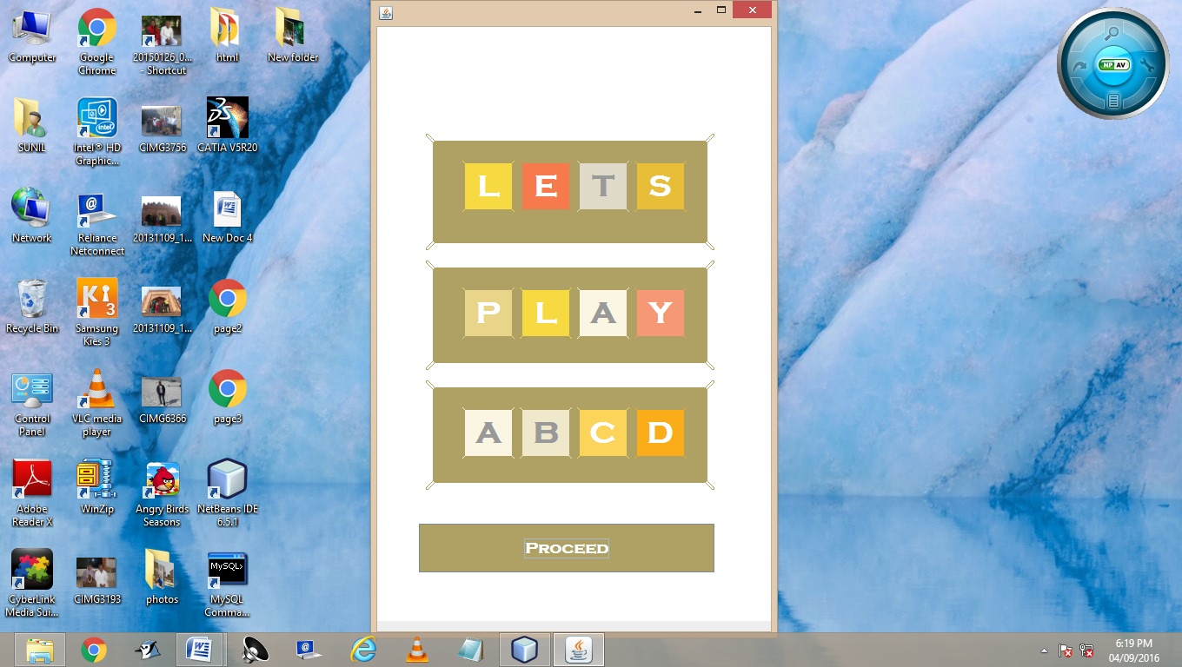

Menu Frame

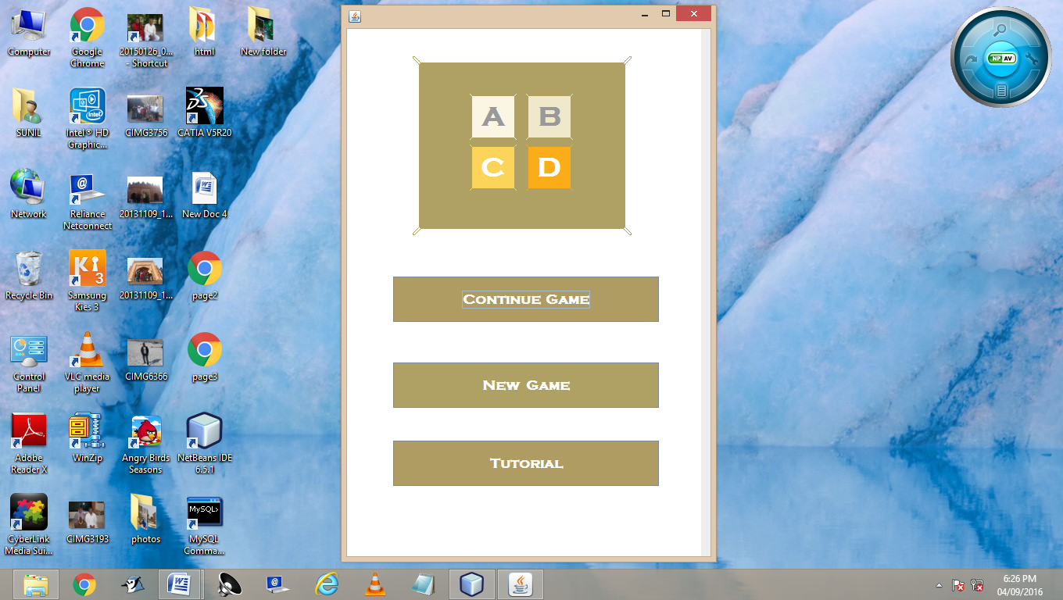

GamePlay Frame

(For New Game)

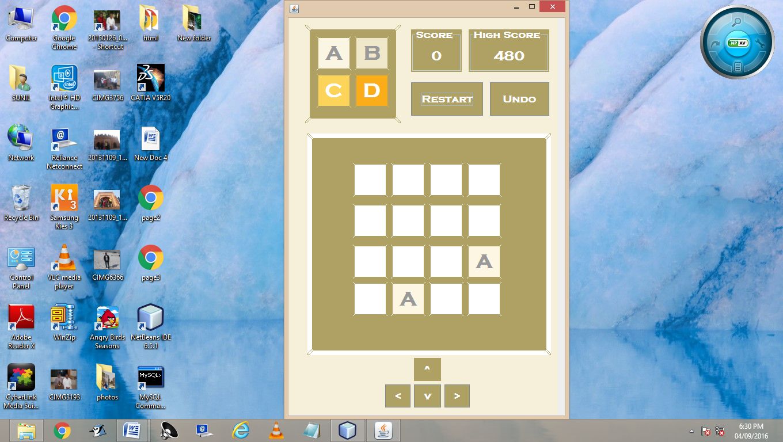

GamePlay Frame

(For Continue Game)

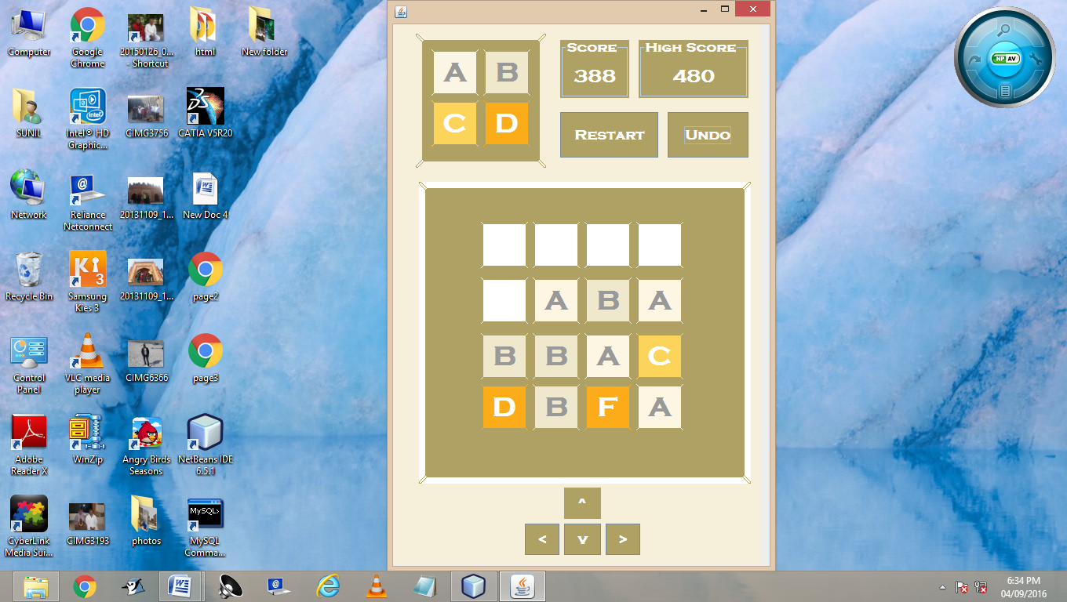

Button Functionality

* Proceed

private void ProceedBtnActionPerformed(java.awt.event.ActionEvent evt) {

Menu menu1 = new Menu();

menu1.setVisible(true);

Title.this.setVisible(false);

}

* Continue

private void ContinueBtnActionPerformed(java.awt.event.ActionEvent evt) {

GamePlay game1 = new GamePlay();

game1.UndoBtn.doClick(0);

game1.setVisible(true);

Menu.this.setVisible(false);

}

* New Game

private void NewGameBtnActionPerformed(java.awt.event.ActionEvent evt) {

GamePlay game1 = new GamePlay();

game1.RestartBtn.doClick(0);

game1.setVisible(true);

Menu.this.setVisible(false);

}

TutorialGame Frame

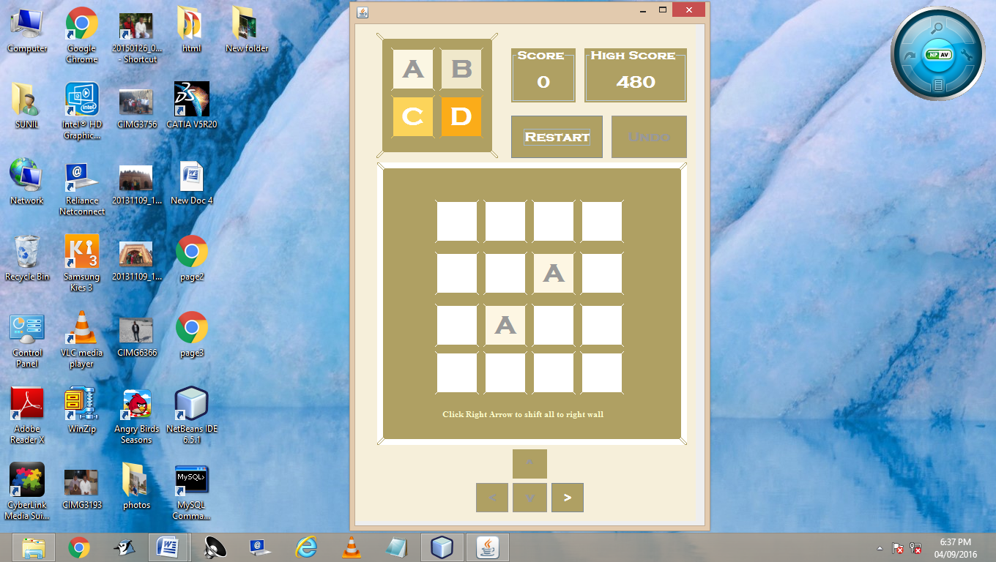

* Tutorial

private void TutBtnActionPerformed(java.awt.event.ActionEvent evt) {

TutorialGame tut1 = new TutorialGame();

tut1.setVisible(true);

tut1.count(0);

tut1.RestartBtn.doClick();

Menu.this.setVisible(false);

}

* TutorialGame Code Extracts

Right Button

if(chance==0){

//Same code as right Button

downBtn.setEnabled(true);

rightBtn.setEnabled(false);

GuideLabel.setText("Click Down to Combine and make a B");

chance=1;

}

else if (chance>=2){

rightBtn.doClick();

}

On clicking right button

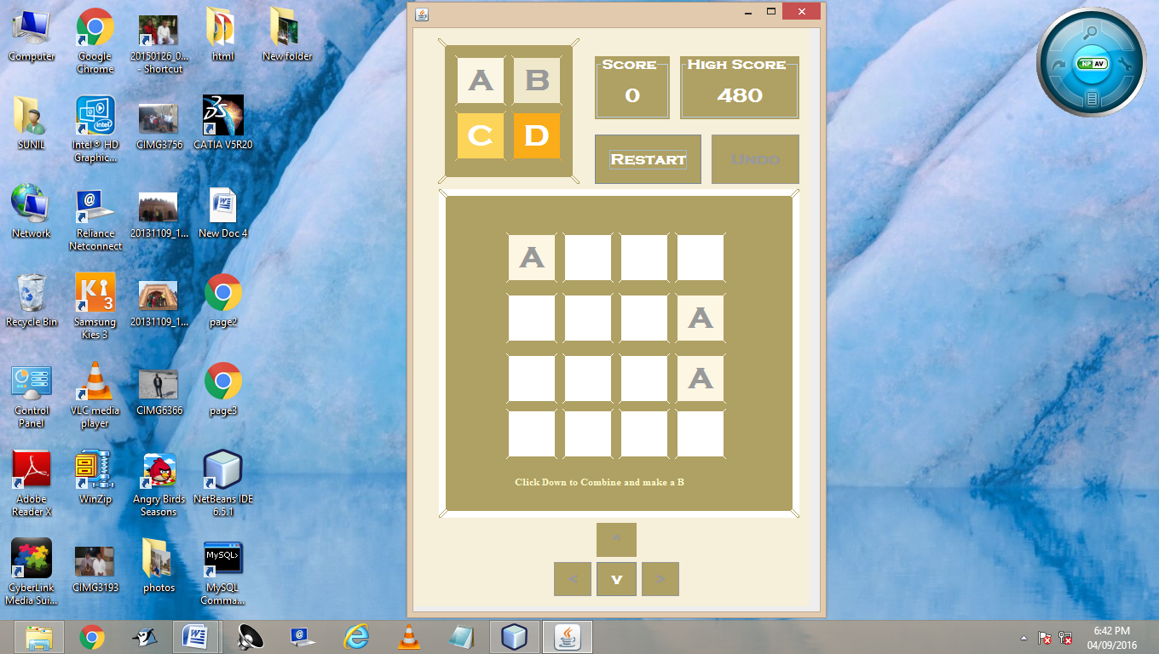

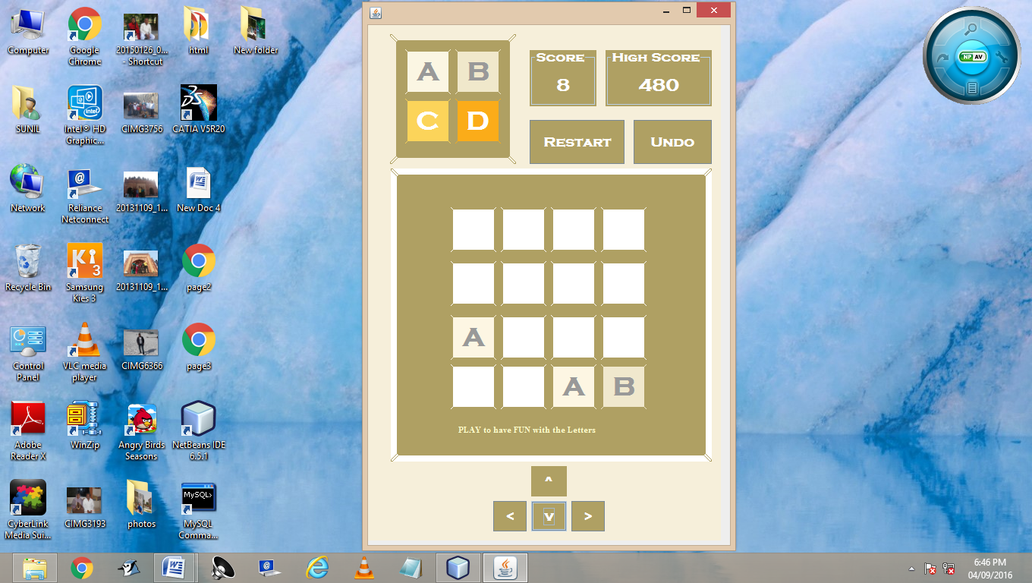 On Clicking Down Button

Down Button

if(chance==0){

//Same code as down Button

upBtn.setEnabled(true);

rightBtn.setEnabled(true);

leftBtn.setEnabled(true);

UndoBtn.setEnabled(true);

GuideLabel.setText("PLAY to have FUN with the Letters");

chance=2;

}

else if (chance>=2){

downBtn.doClick();

}

Restart Button

if (chance==0){

//just before try bock as in Restart **Button**

upBtn.setEnabled(false);

downBtn.setEnabled(false);

leftBtn.setEnabled(false);

UndoBtn.setEnabled(false);

//try block and catch

}

else if(chance>0 && chance <= 2){

chance=0;

RestartBtn.doClick();

rightBtn.setEnabled(true);

}

else{

GamePlay game1 = new GamePlay();

game1.setVisible(true);

game1.RestartBtn.doClick();

TutorialGame.this.setVisible(false);

}

valueAssign();

for(int i =0;i<=3;i++ ) {

for(int j=0;j<=3;j++) {

colourAllot(i,j,index [i][j]);

}

}

colourAssign();

}

* Restart

private void RestartBtnActionPerformed(java.awt.event.ActionEvent evt) {

hscFlag=0;

score=0;

int a=(int)((Math.random()*4));

int b=(int)((Math.random()*4));

int c=(int)((Math.random()*4));

int d=(int)((Math.random()*4));

while(a==c&&b==d) {

c=(int)((Math.random()*4));

d=(int)((Math.random()*4));

}

for(int i=0;i<=3;i++){

for(int j=0;j<=3;j++) {

index[i][j]=' ';

}

}

index[a][b]='A';

index[c][d]='A';

valueAssign();

try{

Class.forName("java.sql.DriverManager");

 Connection con=(Connection)DriverManager.getConnection("jdbc:mysql://localhost:3306/project12","root","123");

Statement stmt =(Statement)con.createStatement();

String query="Delete from Saved_Game;";

stmt.executeUpdate(query);

for(int l=0;l<16;l++){

int i=l/4;

int j=l%4;

String query1="Insert into Saved_Game values ('"+i+j+"','"+index[i][j]+"','"+index[i][j]+"');";

stmt.executeUpdate(query1);

}

String query1="Insert into Saved_Game values ('sc','0','0');";

stmt.executeUpdate(query1);

String query2="Select hsc from HScore where rank = 1;";

ResultSet rs = stmt.executeQuery(query2);

if(rs.next())

hscore=Long.parseLong(rs.getString("hsc"));

highScoreLabel.setText(""+hscore);

}

catch(Exception e){

JOptionPane.showMessageDialog(this,e.getMessage());

}

GamePlay Frame

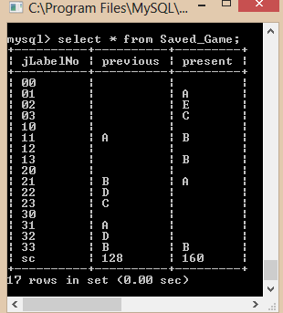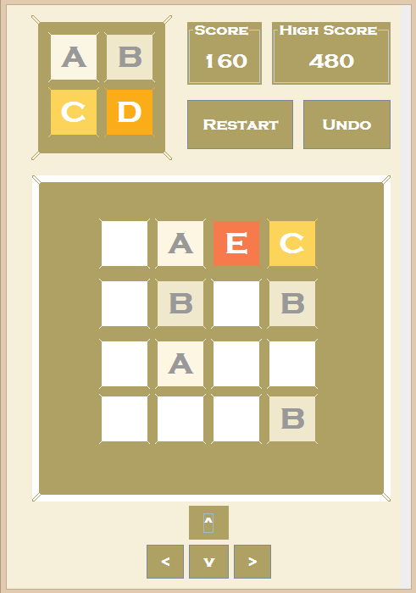Before clicking Left button SQL table before clicking leftBtn

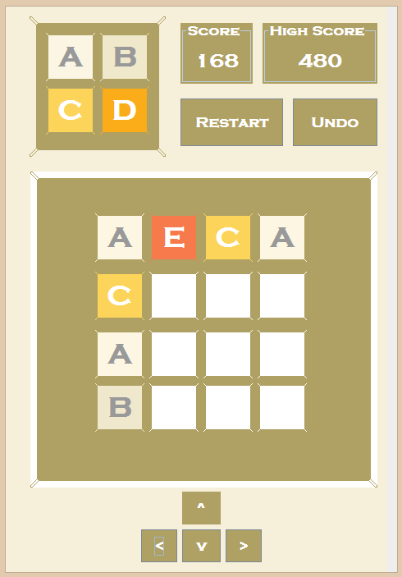 Before Clicking Undo Button

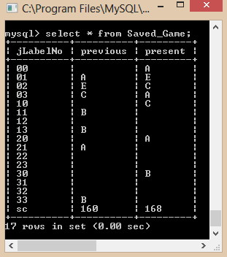SQL table before clicking undoBtn

 for(int i =0;i<=3;i++ ) {

for(int j=0;j<=3;j++) {

colourAllot(i,j,index [i][j]);

}

}

colourAssign();

}

* Undo

private void UndoBtnActionPerformed(java.awt.event.ActionEvent evt) {

try{

Class.forName("java.sql.DriverManager");

Connection con=(Connection)DriverManager.getConnection("jdbc:mysql://localhost:3306/project12","root","123");

Statement stmt =(Statement)con.createStatement();

for(int l=0;l<16;l++){

int i=l/4;

int j=l%4;

String query1="Update Saved_Game set present = previous where jLabelNo = '"+i+j+"';";

stmt.executeUpdate(query1);

}

String query1="Update Saved_Game set present = previous where jLabelNo = 'sc';";

After clicking Undo button 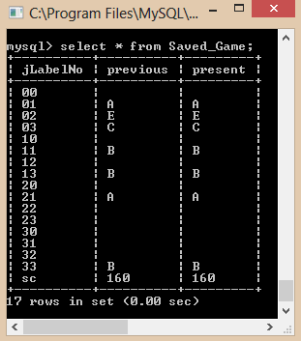 SQL table after clicking undoBtn

 stmt.executeUpdate(query1);

for(int i=0;i<=3;i++){

for(int j=0;j<=3;j++){

String query="Select Present from Saved_Game where jLabelNo = '"+i+j+"';";

ResultSet rs = stmt.executeQuery(query);

if(rs.next())

index[i][j]=(rs.getString("Present")).charAt(0);

}

}

String query="Select Previous from Saved_Game where jLabelNo = 'sc';";

ResultSet rs = stmt.executeQuery(query);

if(rs.next())

score=Long.parseLong(rs.getString("Previous"));

String query2="Select hsc from HScore where rank = 1;";

rs = stmt.executeQuery(query2);

if(rs.next())

hscore=Long.parseLong(rs.getString("hsc"));

highScoreLabel.setText(""+hscore);

valueAssign();

for(int i =0;i<=3;i++ ) {

for(int j=0;j<=3;j++) {

colourAllot(i,j,index [i][j]);

GamePlay Frame

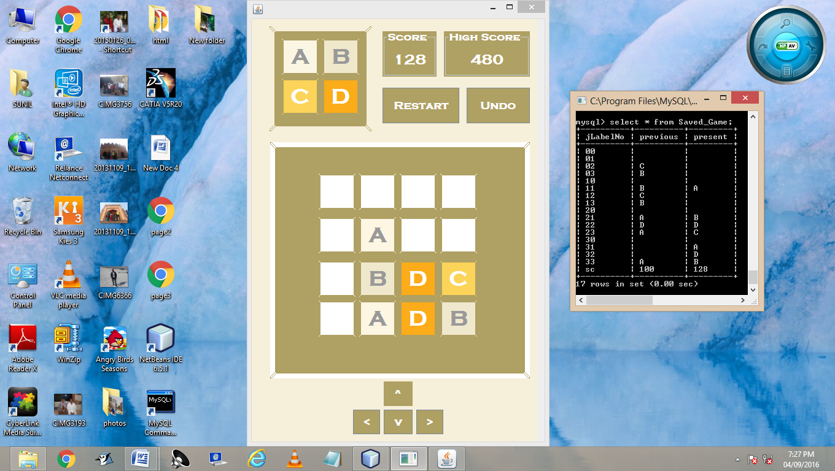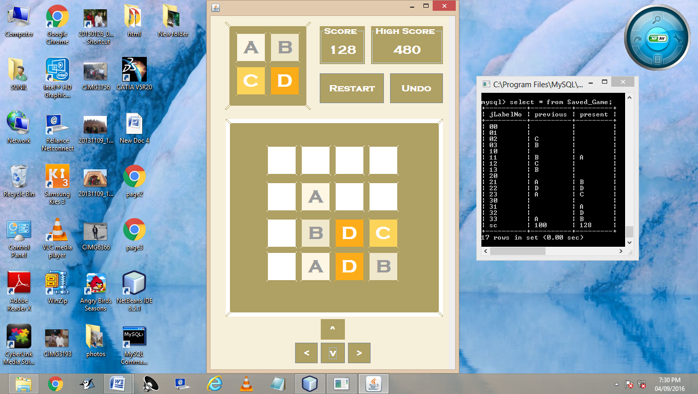Before clicking Up button SQL table before clicking upBtn

 On Clicking Up Button

SQL table on clicking upBtn

 }

}

colourAssign();

}

catch(Exception e){

JOptionPane.showMessageDialog(this,e.getMessage());

}

}

* UP

private void upBtnActionPerformed(java.awt.event.ActionEvent evt) {

direction = 1;

for(int i=0;i<=3;i++) {

for(int j = 0;j<=3;j++) {

testCombine[i][j]=true;

}

}

for(int i=0;i<=3;i++) {

for(int j=0;j<=3;j++) {

index1[i][j]=index[i][j];

}

}

int key=0;

for(int i=0;i<=3;i++) {

 for(int j=0;j<=3;j++) {

if(index[i][j]!=' ') {

key=1;

}

}

}

if(key==0)

JOptionPane.showMessageDialog(this,"Please start the game first");

goUp();

valueAssign();

for(int i =0;i<=3;i++ ) {

for(int j=0;j<=3;j++) {

colourAllot(i,j,index [i][j]);

}

}

colourAssign();

delay();

score= Long.parseLong(scoreLabel.getText());

try

{

Class.forName("java.sql.DriverManager");

 Connection con=(Connection)DriverManager.getConnection("jdbc:mysql://localhost:3306/project12","root","123");

Statement stmt =(Statement)con.createStatement();

String query2="Select hsc from HScore where rank = 1;";

ResultSet rs = stmt.executeQuery(query2);

if(rs.next())

hscore=Long.parseLong(rs.getString("hsc"));

if(score>hscore){

hscore=score;

highScoreLabel.setText(""+hscore);

if(hscFlag==0){

JOptionPane.showMessageDialog(this,"New High score Achieved");

hscFlag=1;

}

}

String query3="Update HScore set hsc = "+hscore+" where rank = 1;";

stmt.executeUpdate(query3);

}

catch(Exception e){

JOptionPane.showMessageDialog(this,e.getMessage());

}

}

GamePlay Frame

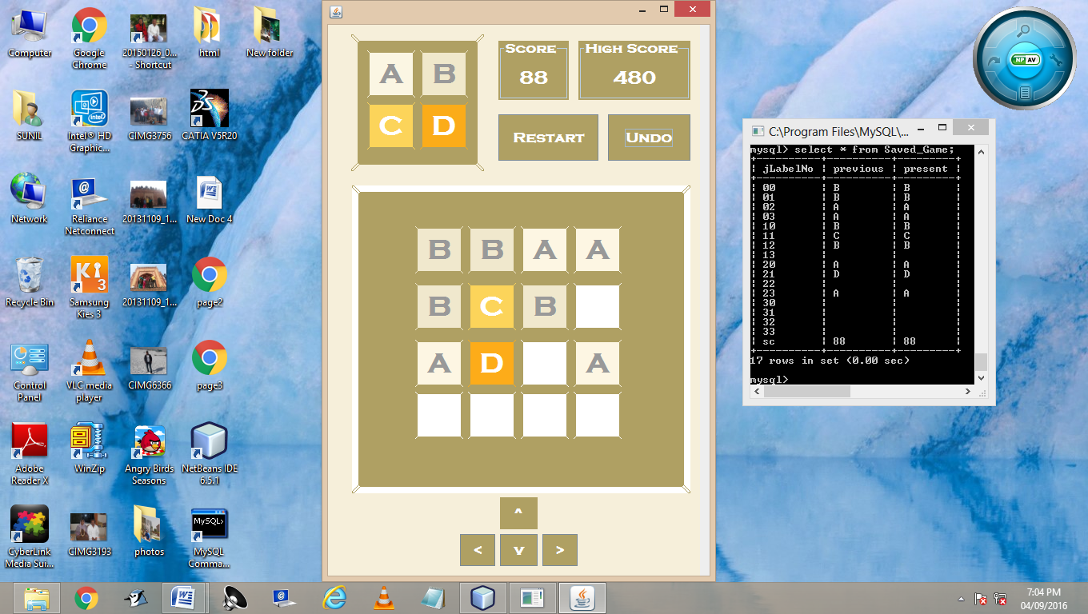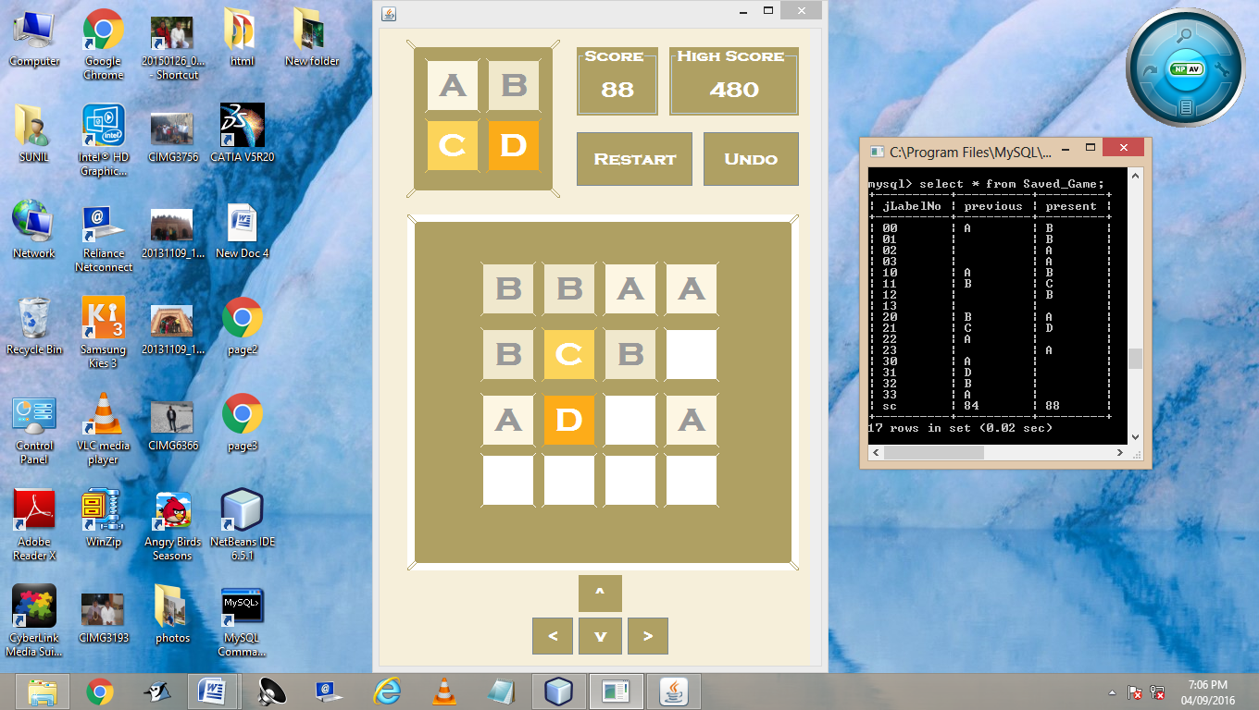Before clicking right button SQL table before clicking rightBtn

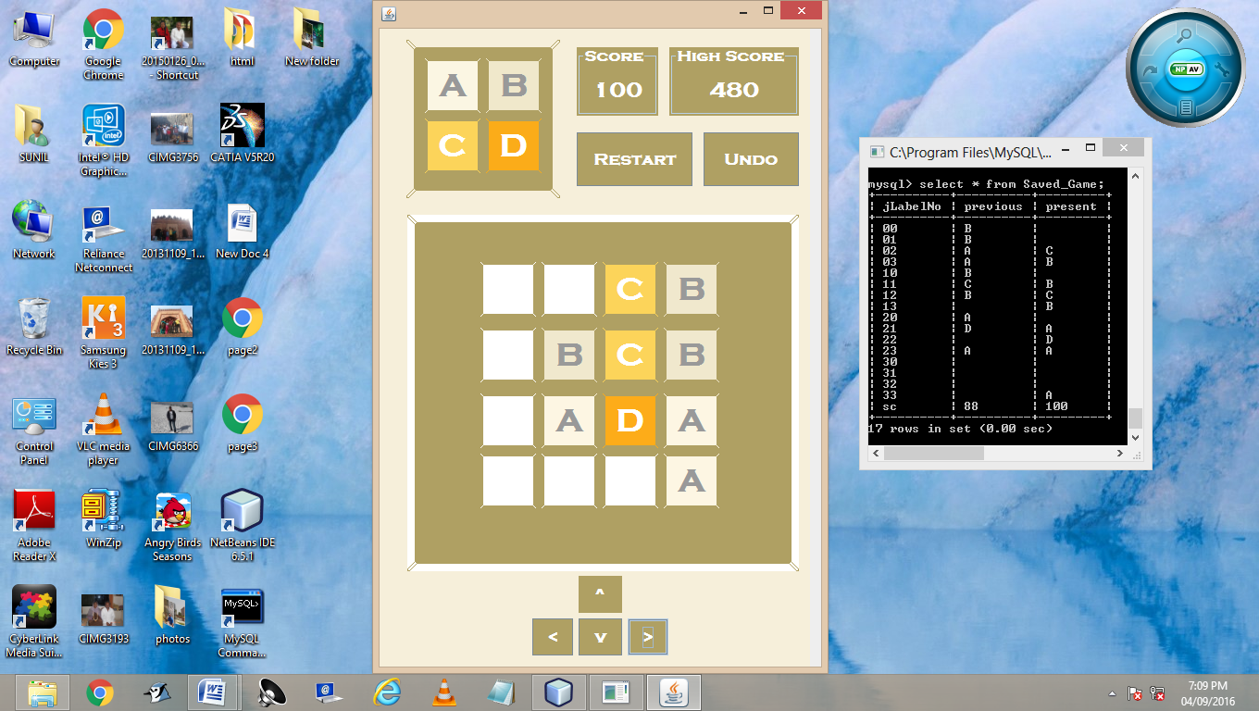 On Clicking Right Button

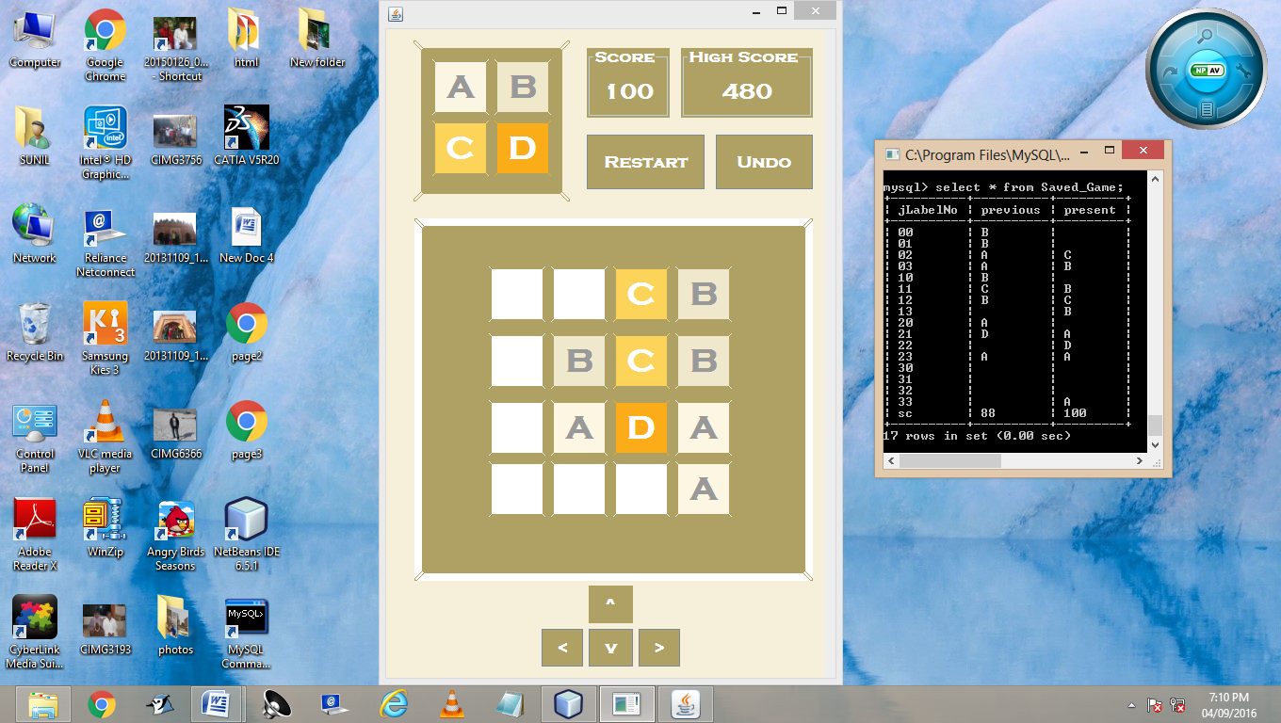SQL table on clicking rightBtn

*  Right

private void rightBtnActionPerformed(java.awt.event.ActionEvent evt) {

direction = 4;

for(int i=0;i<=3;i++) {

for(int j = 0;j<=3;j++) {

testCombine[i][j]=true;

}

}

for(int i=0;i<=3;i++) {

for(int j=0;j<=3;j++) {

index1[i][j]=index[i][j];

}

}

int key=0;

for(int i=0;i<=3;i++) {

for(int j=0;j<=3;j++) {

if(index[i][j]!=' ') {

key=1;

}

}

}

if(key==0)

JOptionPane.showMessageDialog(this,"Please start the game first");

goRight();

valueAssign();

for(int i =0;i<=3;i++ ) {

for(int j=0;j<=3;j++) {

colourAllot(i,j,index [i][j]);

}

}

 colourAssign();

delay();

score= Long.parseLong(scoreLabel.getText());

try{

Class.forName("java.sql.DriverManager");

Connection con=(Connection)DriverManager.getConnection("jdbc:mysql://localhost:3306/project12","root","123");

Statement stmt =(Statement)con.createStatement();

String query2="Select hsc from HScore where rank = 1;";

ResultSet rs = stmt.executeQuery(query2);

if(rs.next())

hscore=Long.parseLong(rs.getString("hsc"));

if(score>hscore){

hscore=score;

GamePlay Frame

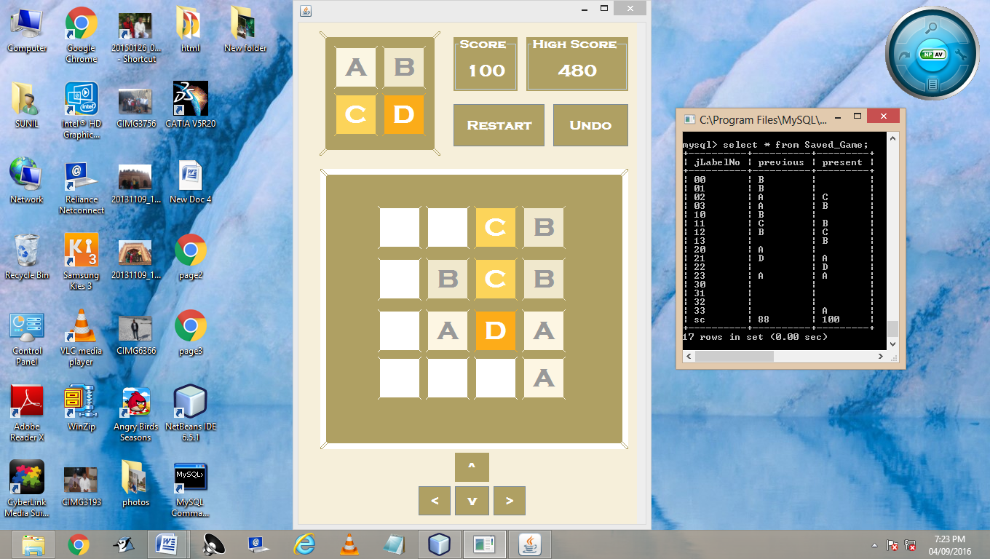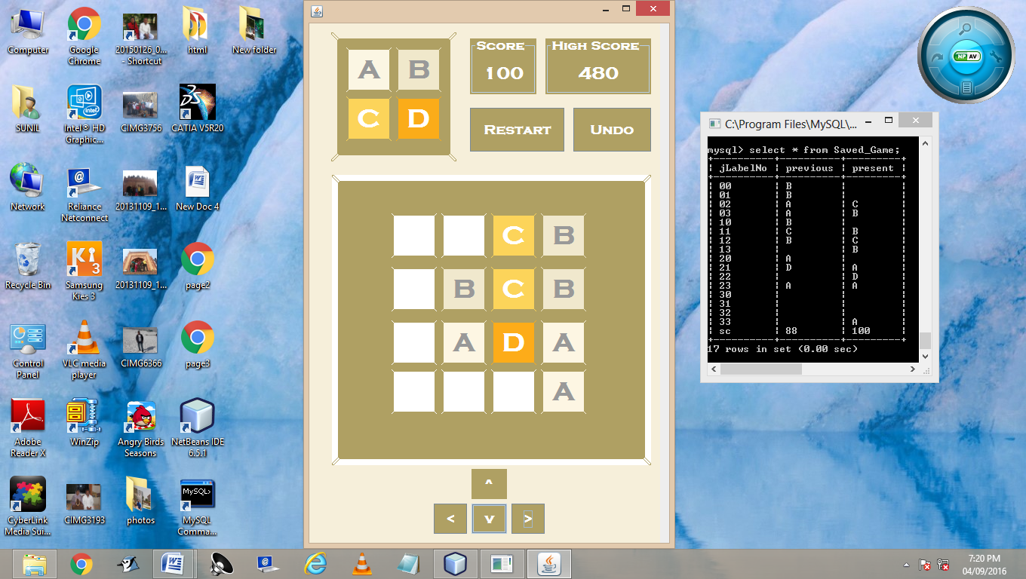Before clicking down button SQL table before clicking downBtn

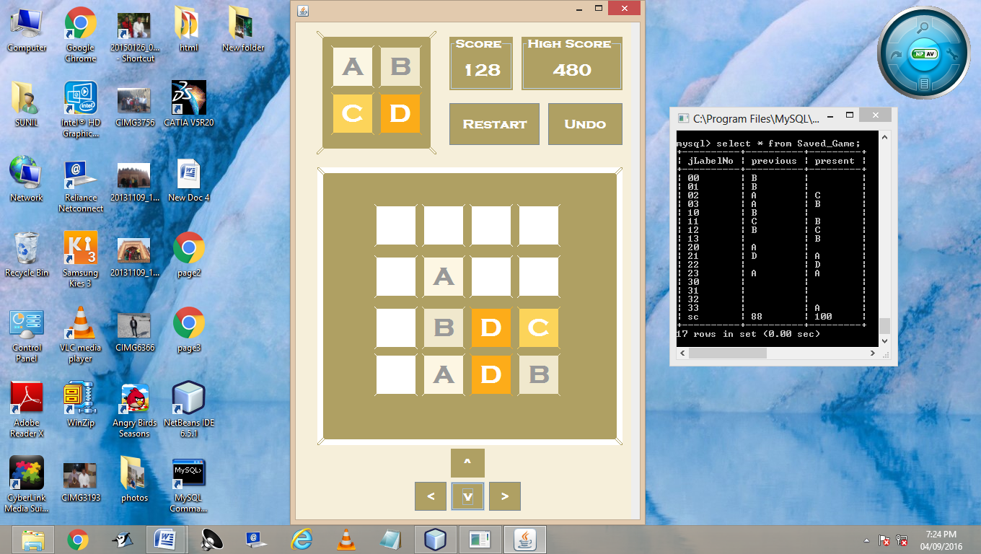 On Clicking Down Button

SQL table on clicking downBtn

 highScoreLabel.setText(""+hscore);

if(hscFlag==0){

JOptionPane.showMessageDialog(this,"New High score Achieved");

hscFlag=1;

}

}

String query3="Update HScore set hsc = "+hscore+" where rank = 1;";

stmt.executeUpdate(query3);

}

catch(Exception e){

JOptionPane.showMessageDialog(this,e.getMessage());

}

}

* Down

private void downBtnActionPerformed(java.awt.event.ActionEvent evt) {

direction = 2;

for(int i=0;i<=3;i++) {

for(int j = 0;j<=3;j++) {

testCombine[i][j]=true;

}

}

for(int i=0;i<=3;i++) {

 for(int j=0;j<=3;j++) {

index1[i][j]=index[i][j];

}

}

int key=0;

for(int i=0;i<=3;i++) {

for(int j=0;j<=3;j++) {

if(index[i][j]!=' ') {

key=1;

}

}

}

if(key==0)

JOptionPane.showMessageDialog(this,"Please start the game first");

goDown();

valueAssign();

for(int i =0;i<=3;i++ ) {

for(int j=0;j<=3;j++) {

colourAllot(i,j,index [i][j]);

}

}

colourAssign();

delay();

 score= Long.parseLong(scoreLabel.getText());

try{

Class.forName("java.sql.DriverManager");

Connection con=(Connection)DriverManager.getConnection("jdbc:mysql://localhost:3306/project12","root","123");

Statement stmt =(Statement)con.createStatement();

String query2="Select hsc from HScore where rank = 1;";

ResultSet rs = stmt.executeQuery(query2);

if(rs.next())

hscore=Long.parseLong(rs.getString("hsc"));

if(score>hscore){

hscore=score;

highScoreLabel.setText(""+hscore);

if(hscFlag==0){

JOptionPane.showMessageDialog(this,"New High score Achieved");

hscFlag=1;

}

}

String query3="Update HScore set hsc = "+hscore+" where rank = 1;";

stmt.executeUpdate(query3);

}

catch(Exception e){

GamePlay Frame

Before clicking Left button SQL table before clicking leftBtn

 On Clicking Left Button

SQL table on clicking leftBtn

 JOptionPane.showMessageDialog(this,e.getMessage());

}

}

* Left

private void leftBtnActionPerformed(java.awt.event.ActionEvent evt) {

direction = 3;

for(int i=0;i<=3;i++) {

for(int j = 0;j<=3;j++) {

testCombine[i][j]=true;

}

}

for(int i=0;i<=3;i++) {

for(int j=0;j<=3;j++) {

index1[i][j]=index[i][j];

}

}

int key=0;

for(int i=0;i<=3;i++) {

for(int j=0;j<=3;j++) {

if(index[i][j]!=' ') {

key=1;

}

}

 }

if(key==0)

JOptionPane.showMessageDialog(this,"Please start the game first");

goLeft();

valueAssign();

for(int i =0;i<=3;i++ ) {

for(int j=0;j<=3;j++) {

colourAllot(i,j,index [i][j]);

}

}

colourAssign();

delay();

score= Long.parseLong(scoreLabel.getText());

try{

Class.forName("java.sql.DriverManager");

Connection con=(Connection)DriverManager.getConnection("jdbc:mysql://localhost:3306/project12","root","123");

Statement stmt =(Statement)con.createStatement();

String query2="Select hsc from HScore where rank = 1;";

ResultSet rs = stmt.executeQuery(query2);

if(rs.next())

hscore=Long.parseLong(rs.getString("hsc"));

 if(score>hscore){

hscore=score;

highScoreLabel.setText(""+hscore);

if(hscFlag==0){

JOptionPane.showMessageDialog(this,"New High score Achieved");

hscFlag=1;

}

}

String query3="Update HScore set hsc = "+hscore+" where rank = 1;";

stmt.executeUpdate(query3);

}

catch(Exception e){

JOptionPane.showMessageDialog(this,e.getMessage());

}

}